Go to <https://mainspring.cognizant.com>

Click on left pane -------------🡪 Click on Project “Travelport ACS Replatform”

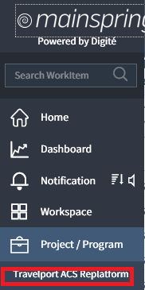

Click on **MONITOR --------🡪Reports**

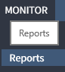

Click on **Resource Loading** to download the excel sheet having all the resource name for this project and number of planned hours assigned to each resource. Filter out all resource details which is having planned hours > 0.

To download the excel click on Print icon as below.

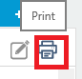

Click on **Plan ---🡪 Releases**

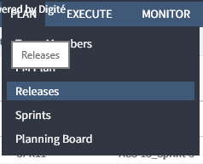

Click on **REL1**

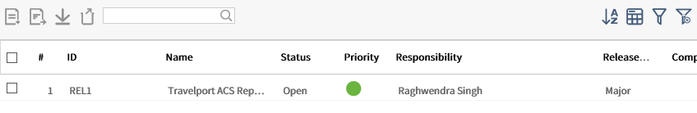

Change the Estimated End Date to next month date and save it. For example, currently the activity is created for the month FEB-2018 so I have changed the Estimated End Date to 09-MAR-2018.

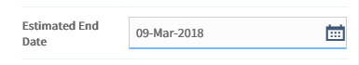

Click on **Plan------🡪 Sprints**

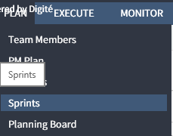

Click on **+Icon** to create a new Sprint.

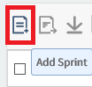

Fill the Sprint details as shown in below screen shot and save it.

**Name** = “Current Sprint Name”

**Estimated Start date**=” The current month working start date”

**Estimated End Date** will be populated automatically.

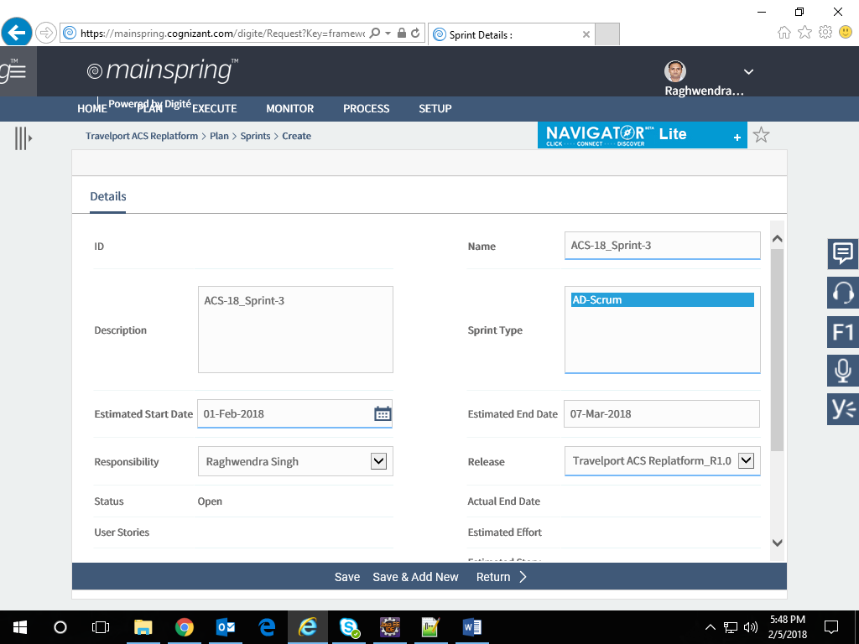

Click on **Execute-------🡪 User Stories**

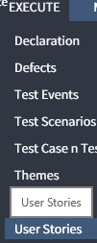

Click on +icon to create a new user story.

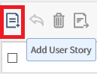

Fill the details as shown in below screen shot and save it.

**Name** = Name of the user story. Take the number one higher than the current user story number. For example, if the last user story name is US12 then the next user story name will be US13

**Description** = Same as Name

**Card Owner** = Your name

**Priority** = Medium

**State** = Planned

**Due Date** = Month End Date

**Sprint** = Current Sprint which is created in previous step.

**Estimate and Actual story points** = 10

Create one user story for 4 team members. For example, if there are 28 team members present in the **Resource Loading** excel sheet downloaded in previous step, then there will be 7 user stories created and 4 team members will be assigned to one user story and so on.

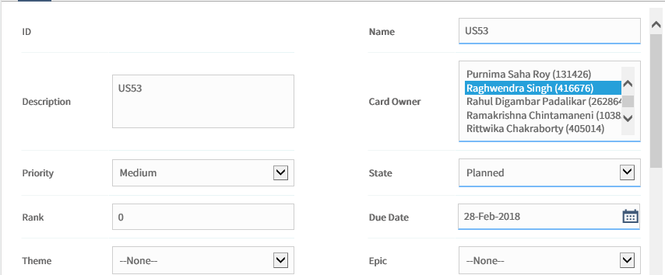

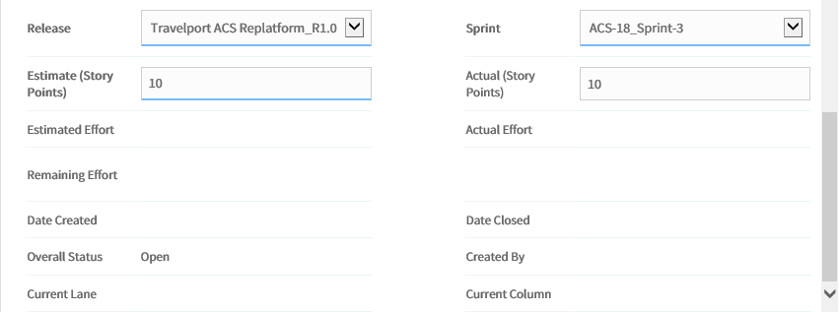

Once the user story is **saved,** click on “ToDos” icon as mentioned below.

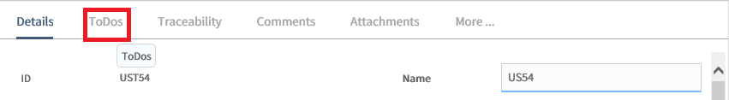

Click on **Add** to add the task for each team member under this created user story. Create four task for four team members from excel sheet and provide the details as mentioned below. **The Estimated value is the number of hours assigned to the team member in the resource loading excel sheet. There can be difference in number of hours for onsite and offshore team members for the particular month based on the organization holiday.**

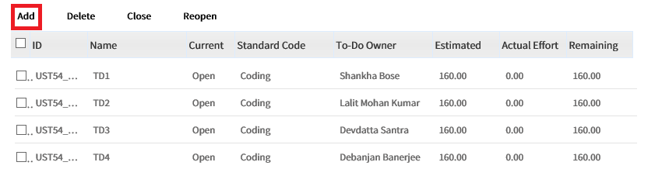

*************************************************************************************

Once all the user stories and tasks under the user stories are created, you need to fill the time for every week and submit the same. This needs to be done for all the weeks under that month.

Click on left pane **Workspace-----🡪My Workspace**

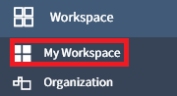

Click on **TIMESHEET----🡪Time Tracking**

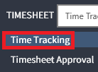

Select resource name one by one, fill 8-hour time and click on save link. You can submit the entire week time sheet only at the last working week day. For example, either you can submit it on every Friday or fill the 8 hours for entire month and save it and submit at the month end. It is better to submit weekly/bi-weekly.

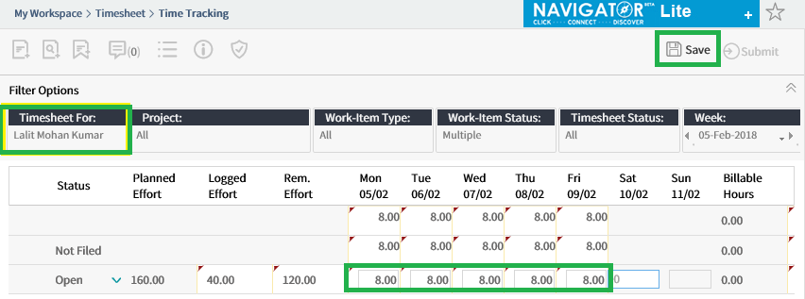

If any new resource added in the excel sheet, then to fill the timesheet for that resource, you need to delegate his timesheet to you as shown below.

Go to **PROCESS---------🡪** Timesheet Delegation

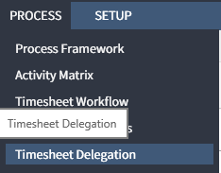

Select the resource name and click on **Manage Delegates** button

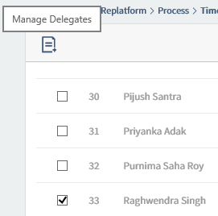

Select the name of delegators from **Team Members** and **Add** the delegates and save it. Now you will be able to fill the timesheet for the selected resource.

